**Wolfe Family Ancestors**

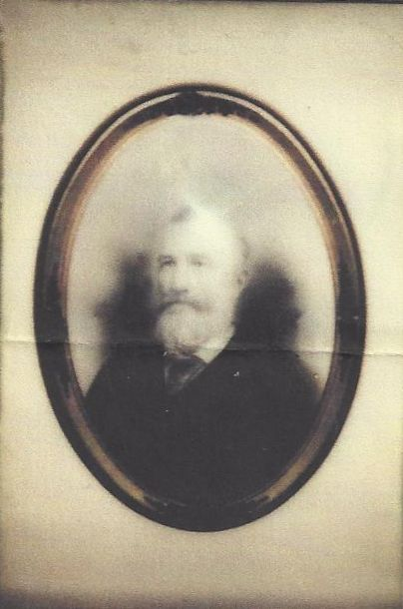

**Benjamin Franklin Wolfe – 1895 (est.)**

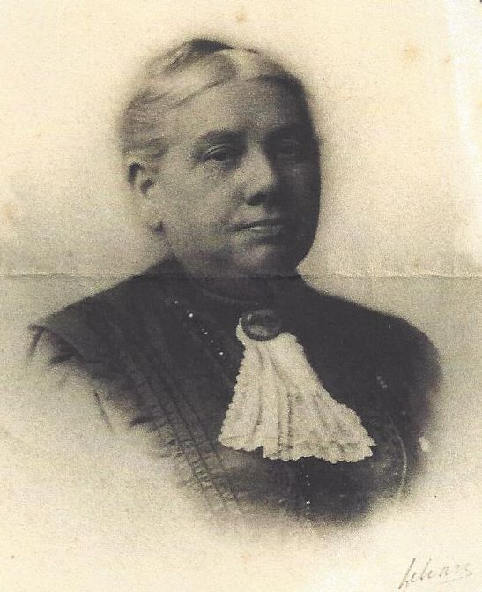

**Clarisa “Clara” W. Bunn Wolfe**

**Wife of Benjamin Franklin Wolfe – about 1920 (est.)**